**IS SACHIN TENDULKAR THE BEST PLAYER..??**

Being a fan of Sachin Tendulkar right from the childhood, I always thought that Sachin is the world’s best cricketer. I recently had a conversation with my friend who says that there are many other players who does better than Sachin. I wondered..!! I thought if I could perform an analysis to know the best player. I started searching for tools to perform analysis on Sachin’s performance over other top players. My professor advised me to use SAP Lumira and SAP Predictive Analysis.

I have done an analysis on the top 5 batsmen and top 5 bowlers of One Day International (ODI) cricket matches.

**DATA SOURCE:**

I have collected the data from <http://www.espncricinfo.com/>

My data contains details about top 10 players as mentioned above in ODI cricket matches.

**TOOLS USED:**

* SAP Lumira
* SAP Predictive Analysis
* SAP HANA Cloud Platform

**ANALYSIS 1:**

My first analysis is to look for the **Time Span** i.e. for how many years the players have been in the field of cricket.

This shows that Sachin has been in the field for 24 years and that is really a long span for a player that affects the generations who carry the name of Sachin.

Lowest span = 10 years

Highest span = 24 years

Average span = 15.6 years

Sachin’s time span > Average span

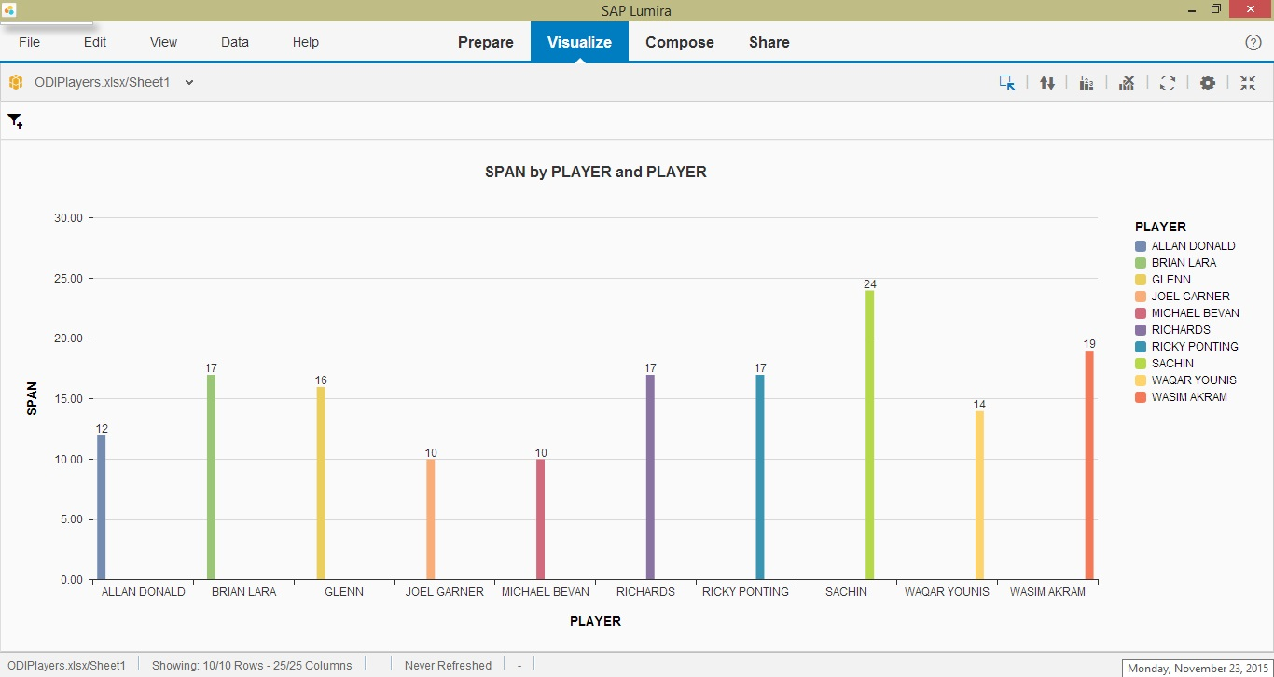

Fig 1: Analysis on time span of the players

**ANALYSIS 2:**

Comparing the **Batting Average** of the players individually i.e,

The total number of runs the player has scored divided by number of times the player has been out.

This clearly shows that Michael and Richards play better than Sachin.

1. Michael Bevan – 53.58
2. Richards – 47.00
3. Sachin – 44.83

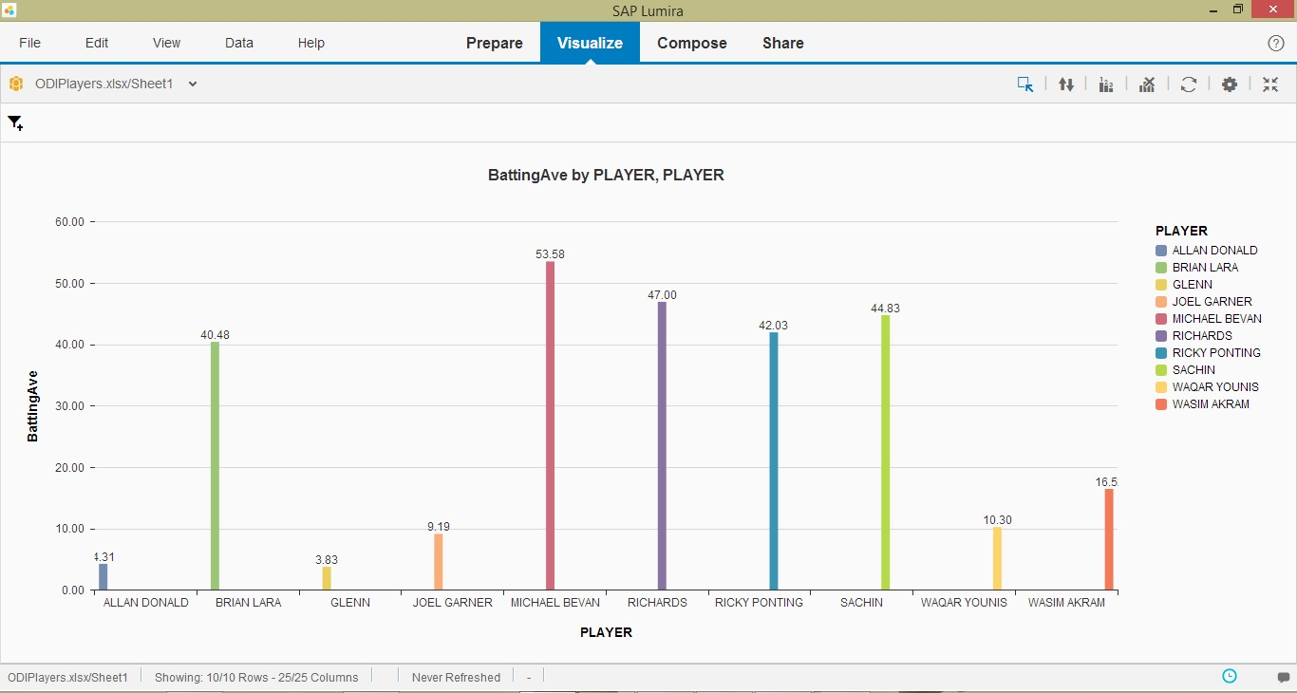

Fig 2: Analysis on Batting Average

**ANALYSIS 3:**

Analysis on **Batting Strike Rate/ Runs Average** which is defined as average number of runs scored per 100 balls faced.

Sachin stands in 3rd position after Richards and Wasim.

1. Richards – 0.90
2. Wasim Akram – 0.88
3. Sachin – 0.86

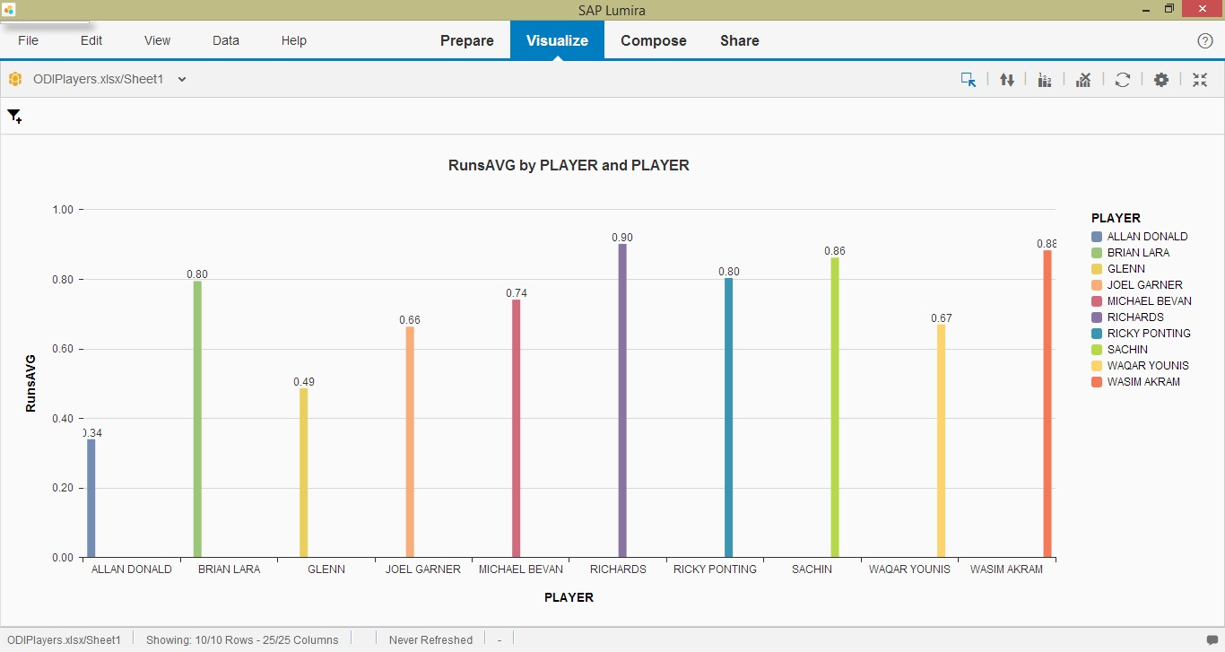

Fig 3: Analysis on Runs Average

**ANALYSIS 4:**

The **Bowling Strike Rate** and **Batting Strike Rate** of individual players using WORD CLOUD.

The larger the font, the better is the player’s Bowling strike rate. The darker the colour, the better is his Batting strike rate.

And this clearly shows **Michael** has the best bowling strike rate and **Wasim** **Akram** has the best batting strike rate which again proved Sachin is NOT the best player.

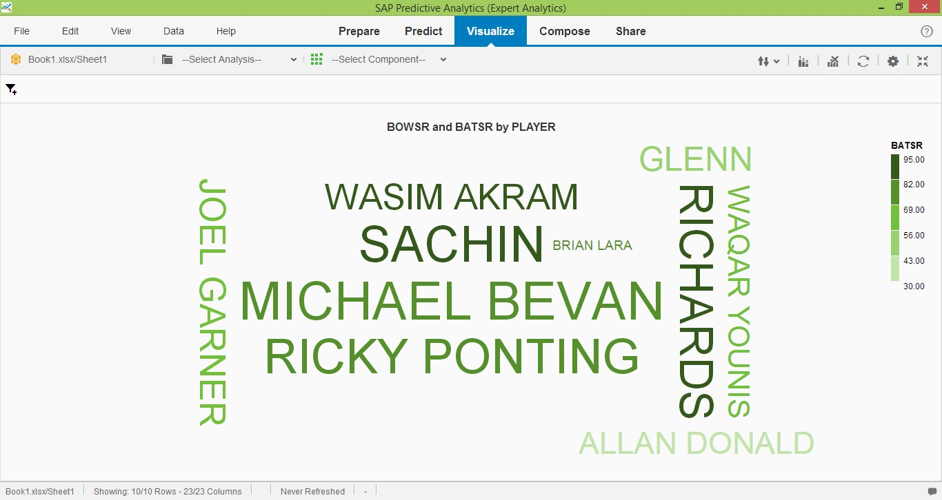

Fig 4: Analysis on bowling strike rate and batting strike rate

**ANALYSIS 5:**

I used **Parallel Co-ordinate Chart** to compare all span, average, number of 100’s scored, batting strike rate and bowling strike rate at a time.

It is similar to interactive plotting of different variables.

The first vertical line indicates span of the players

The second line indicates Average of the players

The third line indicates the number of 100’s hit by a players

The fourth line indicates Batting strike rate of the players

The fifth line indicates bowling strike rate of the players

***This shows that Sachin hit more number of centuries in his career than other players but the bowling strike rate, batting strike rate, average all are less than those of other players records.

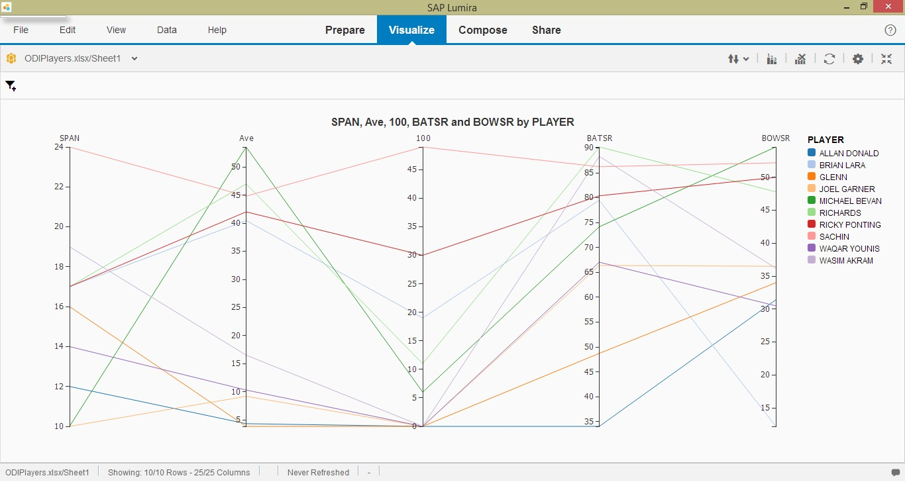

Fig 5: Interactive Plotting

**TWITTER DATA ANALYSIS:**

I have streamed the twitter data on cricket and most of the tweets I got in my tweets table is from the recent cricket match that took place in Houston.

Most of the tweets I got is about Sachin Tendulkar’s efficiency in the match.

It clearly shows the craze Sachin has among the audience.

Coming to reality, Shane Warne had played better compared to Sachin.

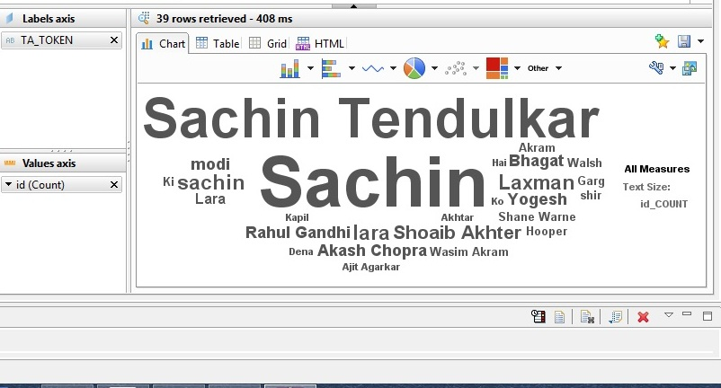

Fig 6: Word Cloud on frequent names from twitter data

**SENTIMENT ANALYSIS:**

On performing the sentiment analysis, more number of people comply with the term that Sachin is the great and the best. This could definitely influence the people surrounding those particular people.

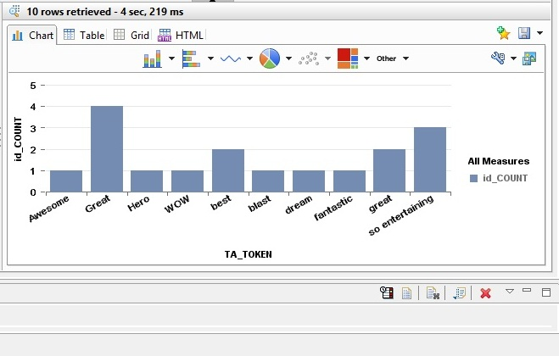

Fig 6: Sentiment Analysis on Twitter Data about Sachin

**SUMMARY:**

From the above analysis, it is clear that Sachin is the most well-known personality as he had been in the field for more than 2 decades.

Sachin had hit more number of centuries (100’s) than any other player and that is why he has become the most well-known cricketer.

From the sentiment analysis, it is undeniable that one person’s thought could definitely affect the people surrounding him and so there are transitive fans to Sachin. In fact, I was one among them.

It is not that I deny Sachin’s greatness but there are many other players who play far better than Sachin.

Coming to **Technology Effects**, there are no proper shoes and bats in the early stages. And this is too an important factor to consider and of course a broad range to be covered.

Hence, this is my analysis.